- You could have indicated frankly what you thought was wrong without embittering them with such _______________________________ criticism.
- His line of questioning was so ______________________________ that I began to suspect that he was not sure of what he was trying to prove.
- If, as you say your slamming of the door on the way out was completely __________________, then you should be more careful in the future.
- Wines from that part of France are produced by _________________________ the juice of the luscious grapes that grow on the hillsides.
- We had hoped to learn his opinion of the new energy program, but he remained completely _________________________ during the interview.
- Who in the world can hope to match the unshakable _____________________ of the indestructible James Bond in moments of great peril?
- No matter what their other likes or dislikes are, most Americans thoroughly ____________________ slavery in all forms.
- We must distinguish between the truly basic policies of our political party and those that are _____________________________and have little connection with the essential program.
- Certain languages such as Afrikaans are the product of ___________________________ and were created when two societies merged.
- As charming, clever, and persuasive as you may be, you will certainly not ____________________ me into lending you my tennis racquet.
- While he remained the nominal leader of the group, the real power passed into the hands of his wily aide.
- The new computerized referral system will greatly _______________________ the processing of complaints by customers.
Determining Meaning – using context clues identify the term that should go in the blank.
- Someone who acquires who new tastes and habits as a result as in spending time in another country experiences is an example of _________________________
- If a mistake is unintentional it is _________________________
- Which of the following is the opposite of exorbitant _______________________
- Actions that are seen as not decisive or definite be described as ________________________
- Mail that needs to be rushed—needs to be _____________________________
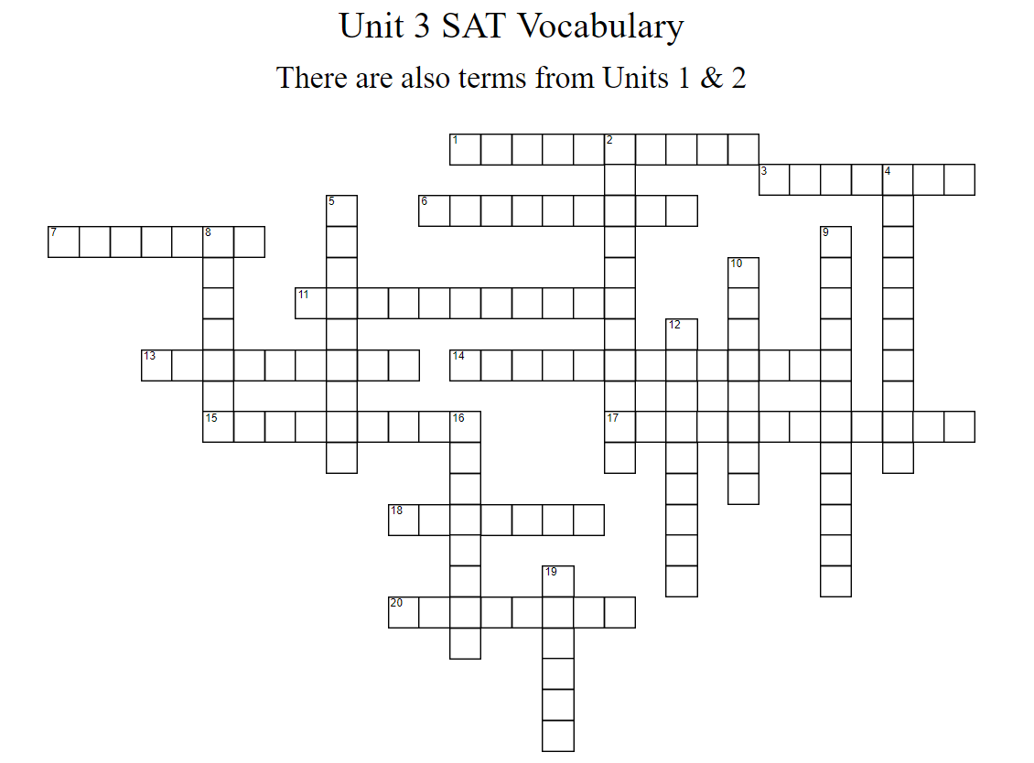
WORD BANK:
ABOMINATE, ACCULTURATION, ADVENTITIOUS, AMELIORATE, ASSUAGE, CALLOW, CIRCUITOUS, EXPEDITE, FERMENT, INADVERTENT, LASSITUDE, NOMINAL, NONCOMMITTAL, PETULANT, PREROGATIVE, SANGFROID, TRANSCEND, UNCTUOUS, VITRIOLIC, WHEEDLE
 | DOWN
 | 2 | accidental
 | 4 | amend, better
 | 5 | withering, acerbic, mordant
 | 8 | titular, inconsequential
 | 9 | extrinsic, incidental, fortuitous
 | 10 | mealymouthed fawning greasy
 | 12 | surpass, outstrip
 | 16 | accelerate, facilitate, speed up
 | 19 | green, raw, unfledged, inexperienced

ACROSS
 | 1 | indirect,meandering, winding
 | 3 | mitigate, slake, allay to quiet to make easier
 | 6 | loathe, abhor, despise, detest
 | 7 | commotion, turmoil, unrest
 | 11 | perquisite, perk
 | 13 | poise, self-assurance equanimity
 | 14 | adaptation
 | 15 | fatigue, lethargy, torpor, languor
 | 17 | cagey, uninformative, playing it safe playing it close to the vest
 | 18 | inveigle, soft-soap, sweet-talk
 | 20 | peevish, annoyed by trifles, easily irritated

