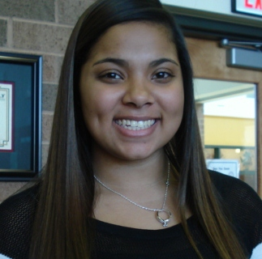

**Mrs. Bell Recommends...**

**Ms. Bell’s 1st Block L it**

**Title:**

**Author:**

**I give this book ___________ stars because:**